Evidence of Ostrea lurida (Carpenter 1864) population structure in Puget Sound, WA

J. Emerson Heare¹, Brady Blake², Jonathan P. Davis³, Brent Vadopalas¹, Steven B. Roberts¹

School of Aquatic and Fishery Sciences, University of Washington¹
Washington Department of Fish and Wildlife²
Puget Sound Restoration Fund³
Seattle, Washington
United States of America

Corresponding Author:
Steven B. Roberts
1122 Boat St.
Seattle, WA 98105
sr320@uw.edu

Abstract
Where restoration efforts occur, such as with Ostrea lurida in Puget Sound, Washington, it is important to consider genetic population structure. Traits that hold adaptive advantage such as reproductive timing and stress resilience may differ at local scales. Using three established populations of O. lurida within Puget Sound Washington, we performed a reciprocal transplant experiment and monitored survival, growth, reproduction. We found that performance differed for each population at each of these three metrics. Ostrea lurida from a relatively harsh home site environment with low primary production and high dynamic habitats exhibited generally greater survival at all sites, whereas those from a relatively lush home site environment with high primary production and lower habitat dynamics exhibited generally greater reproductive activity at all sites. Populations from sites with shorter growing seasons exhibited greater growth in sites with longer growing periods, suggesting a countergradient adaptation may have occurred in these populations.

Keywords: Ostrea lurida, Restoration, Olympia Oyster Growth, Reproduction, Mortality, Adaptation

1. Introduction
Restoration of native species has been of growing concern in the face of habitat loss, reduction of ecosystem services, and global climate change (Anderson, 1995; Lotze et al., 2011). Faced with mounting challenges, resource managers and conservation groups turn to transplantation of viable animals into habitats to supplement dwindling populations and encourage recruitment.
Populations may respond to local selection pressures, and in species with broad geospatial ranges, adaptive differentiation can produce a variety of patterns including countergradient or trait mosaics (Sanford and Kelly, 2011; Conover, 2009). Traits that hold adaptive advantage such as reproductive timing and stress resilience may differ at local scales (Joshi et al., 2001), but can be disrupted by supplementation efforts that may introduce less fit phenotypes into established populations (McKay et al., 2005). For example, salmon species along the Pacific coast are highly variable in phenotypes of return timing, spawn timing, and gametic or somatic growth (Hodgson and Quinn, 2002; O’Malley et al., 2010). In their review, Sanford and Kelly (2011) describe a multitude of studies that determined the scale of adaptations in marine invertebrate species based on local environmental gradients. Less fit supplementation populations would be less effective in creating persistent populations. Without knowledge of the scale of local adaptation, it is nearly impossible to predict the potential efficacy of supplementation.
The Olympia oyster, Ostrea lurida (Carpenter 1864), the only oyster native to the west coast of North America, exists in a wide variety of habitats within its range from Baja California to British Columbia, Canada (Couch and Hassler, 1989). Since the mid 1800’s, O. lurida populations have seen significant declines due overharvest (White et al., 2009), industrial pollution, and sedimentation caused by logging and mining operations (Baker, 1995; White et al., 2009; Blake and Bradbury, 2012). This oyster has been subject to substantial restoration efforts (McGraw, 2009) but information on adaptive stock structure is lacking (Camara and Vadopalas 2009). Even on the relatively small spatial scale of Washington State’s Puget Sound, oceanographic features create diverse habitats in which remnant populations persist. In addition, O. lurida brood their offspring thereby reducing the duration of the migratory life history stage and thus potentially reducing gene flow.
To better predict any possible complication with supplementation efforts on O. lurida populations within the Puget Sound, more extensive research needs to be performed to determine whether local populations vary in performance metrics that may be indicators of local adaptation. Among methods for testing for local adaptation, reciprocal transplant experiments are considered robust (Camara and Vadopalas, 2009), and involve using parent populations from environmentally diverse locales to produce offspring that are placed reciprocally in their home and foreign environments. Population differences in key metrics for fitness can indicate an adaptive advantage and are considered statistically strong (Burford et al., 2014).
The main objective of this study was to determine whether three distinct O. lurida populations from within geographically diverse areas in Puget Sound exhibit differences in survival, reproduction, and growth in different environments. These metrics translate to important life history functions that may be altered due to environmental variables and are possibly heritable within populations. If significant differences exist, future restoration efforts must strive to maintain locally adapted populations.

2. Methods
2.1 Broodstock Conditioning and Outplanting
Adult oysters were collected from three locations in Puget Sound (Fidalgo, Dabob, and Oyster Bay) during November and December 2012. Mass spawning in 24 groups of 20-25 oysters from each location occurred in June 2013 following several months of conditioning. All offspring produced were raised under common conditions. Following setting on microcultch, juveniles were cultured in flowing seawater in Port Gamble, Washington.

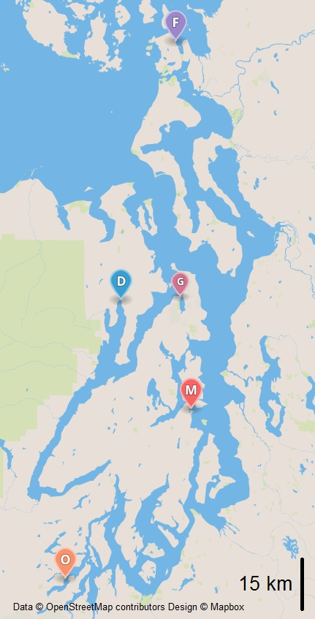

Figure 1. Map of Puget Sound with Broodstock and Outplant Sites. Conditioning site is Port Gamble (G). Broodstock collected from Fidalgo Bay (F), Dabob Bay (D), Oyster Bay (O). Outplanted at Fidalgo Bay (F), Dabob Bay (D), Manchester (M), Oyster Bay (O).

In August 2013, 480 oysters (5-10 mm) from each population were planted at Fidalgo Bay, Oyster Bay, Dabob Bay, and Manchester (Fig. 1). At each site, oysters from each population were placed into four 0.61M X 0.61M growout trays. In each tray, oysters (120) were equally distributed in four 10x7.5cm mesh (1475 micron) bags. Trays were anchored into substrate using steel stakes. In late autumn, trays at Fidalgo Bay, Oyster Bay, and Manchester were transferred from substrate to a mid-column hanging deployment to reduce exposure to extreme temperatures during tidal exchange. At each site, HOBOlogger temperature loggers (OnSet, USA) were deployed to monitor temperature.

2.2 Site Monitoring

2.2.1 Temperature
Minimum and maximum observed temperature for each day was calculated using the R 3.0.3 (R Core Team, 2013) package “plyr” (Wickham, 2014). Number of days above 20 ℃ and below 5 ℃ were determined to be maximum and minimum temperature averages based on previous literature review of O. lurida survival (Couch and Hassler, 1989). Raw data and scripts used in analysis are available (Heare et al., 2014).

2.2.2 Mortality
Mortality was determined via counts of dead oysters or remaining live oysters at each site visit. Survival was assessed in December 2013, January (Dabob only), February, April (Dabob and Manchester only), May (Fidalgo and Oyster Bay only), and June 2014. All trays were examined during winter visits and a single tray was counted each week during June. No oysters remained at Dabob after April. Differences in within site mortality were determined through survdiff tests performed in the R 3.0.3 (R Core Team, 2014) with the R package “survival” (Therneau, 2014). Comparisons with a p-value less than 0.05 were considered different. Plots produced using the R package “plot” (R Core Team, 2014). Raw data and scripts used in analysis are available (Heare et al., 2014).

2.2.3 Growth
Size was assessed via ImageJ analysis (Rasband, 2010) of images taken in August 2013 and again in April (Dabob), September (Oyster Bay), and October 2014 (Fidalgo Bay and Manchester). For each image a reference was measured along with all oysters. For all oysters a linear measurement was made at the longest distance from hinge. Descriptive statistics were produced by the package “pastecs” (Grosjean and Ibanez, 2014). Size distribution was tested for normality with “stats” package (R Core Team, 2014) using the Shapiro-Wilkes test. Growth was compared with “stats” package (R Core Team, 2014) using Kruskal-Wallis assuming non-normal distribution. Pairwise comparisons were performed using Nemenyi PostHoc test using Tukey assumptions (R package “PMCMR” (Pohlert, 2014)). P-values less than 0.05 were considered significantly different. Plots produced using the R package “ggplot2”(Wickham and Chang, 2014). Raw data and scripts used in analysis are available (Heare et al., 2014).

2.2.4 Reproductive Activity
To assess reproductive activity the number of brooding oysters were determined on weekly basis from May 14th until August 15th, 2014 for a total of 15 timepoint observations for each site. This was performed by subjecting trays to anesthesia followed by visual inspection. Specifically, trays were removed from water for 45 minutes then immersed in heptahydrate sulfate mineral epsomite (MgSO4·7H2O) (epsom salt) dissolved in a 50/50 mix freshwater/sea water (75g/l) for 45 minutes. When brooding oysters were detected via visual inspection, larvae were flushed out using ambient sea water onto a 52 micron screen. The screen was then washed with 95% ethanol into a plastic tube (50ml) for later analysis. Each brooder was then measured using calipers for size at brooding. The number brooding adults per site visit was recorded, then arcsine transformed and analyzed via ANOVA and TukeyHSD (R 3.0.3 (R Core Team, 2014) ‘base’ package) test to compare differences across sites, populations, and population by site. Size at at brooding was compared via ANOVA and TukeyHSD. (R 3.0.3 (R Core Team, 2014) ‘base’ package). Plots produced using the R package “ggplot2”(Wickham and Chang, 2014). Raw data and scripts used in analysis are available (Heare et al., 2014).

3. Results
3.1 Site Characteristics
Temperature data was collected throughout the experiment. Oyster Bay had the highest daily minimum temperature (18.43 ℃) in August 2014 while Dabob had the lowest daily minimum temperature (-3.32 ℃) during February 2014 (Fig. 2). The Dabob site experienced the highest number of days outside of the 5-20 ℃ range (85 days). Most of these events (52 days) were below 5 ℃. The Oyster Bay site experience 34 days above 20 ℃ and 5 days below 5 ℃. The Fidalgo site experienced 4 days above 20 ℃ and 20 days below 5 ℃. Manchester experienced no days above or below the temperature averages.
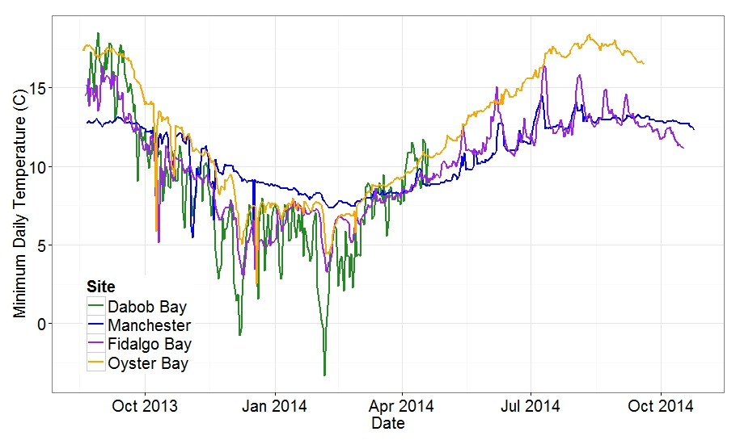
Figure 2. Minimum Observed Daily Temperatures for All Sites. Dabob = Green, Manchester = Blue, Fidalgo Bay = Purple, Oyster Bay = Orange

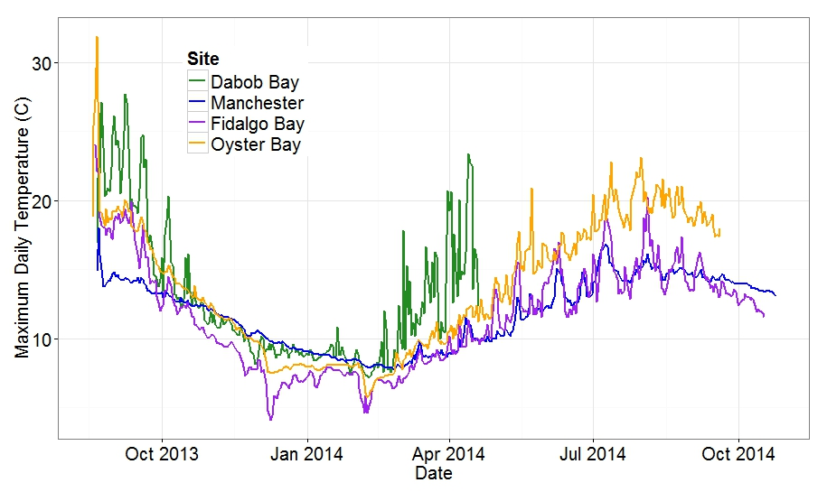
Figure 3. Maximum Observed Daily Temperatures for All Sites. Dabob = Green, Manchester = Blue, Fidalgo Bay = Purple, Oyster Bay = Orange

3.2 Survival
Differences in mortality was observed based on location of origin at three of the four locations. Dabob oysters survived better at Dabob, Oyster Bay, and Manchester (Fig. 4A, 4B, 4C). At Oyster Bay, the native population performed the worse with 37.0% (+/-2.3%) survival (Χ²=76.3, df=2, P=0) (Fig. 1A). Limited mortality was observed at Manchester where at least 80% (Χ²=13.7, df=2, P=0.00105) of oysters remain after 11 months (July 2014) (Fig 4B).
The Dabob Bay location experienced the highest overall mortality, as such the trial was ended prematurely in April 2014. There was also significant differences in mortality across populations (Χ²=141, df=2, P=0), with the Fidalgo oysters having the lowest survival (21.2% +/- 2.1%) (Fig 4C). At the Fidalgo field site, at least 80% of the oysters from all three cohorts remain after 11 months. No differences in mortalities between populations were observed at Fidalgo (Χ²=2.6, df=2, P=0.247) (Fig 4D) .

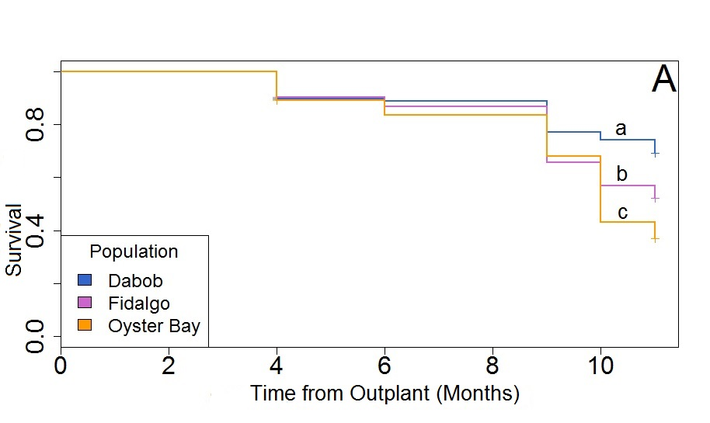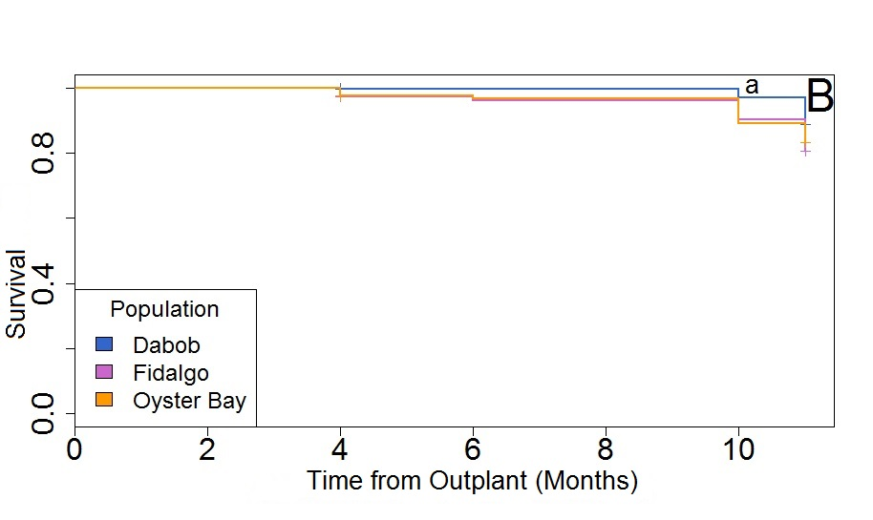
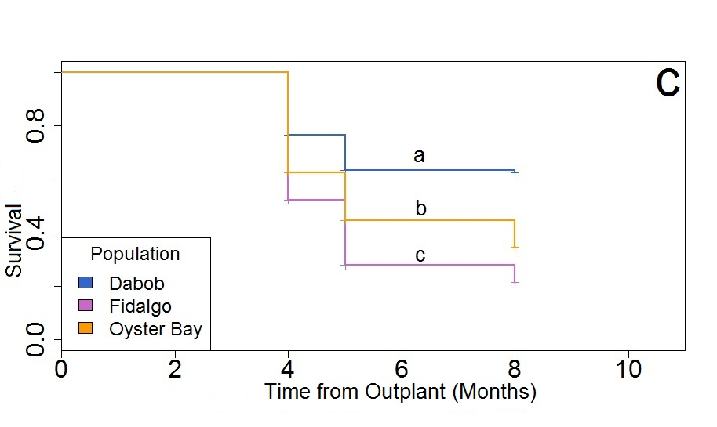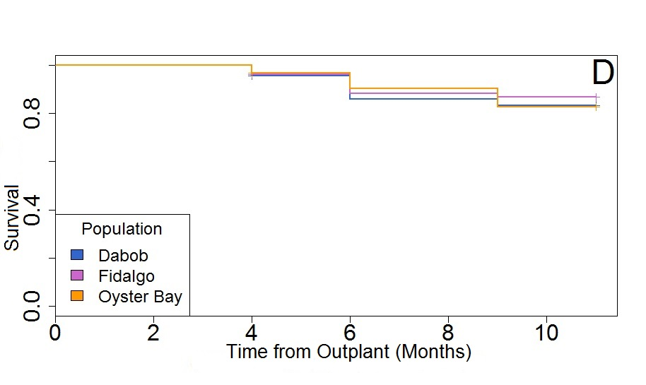

Figure 4. Proportion Survival for Three Oyster Populations. (Dabob = Blue, Fidalgo = purple,. Oyster Bay = orange) at four locations; Oyster Bay (A), Manchester (B), Dabob (C), and Fidalgo (D). Lowercase letters(a,b,c) are significant differences.

3.3 Growth
Mean oyster size at outplant was 11.36 mm (+/-3.15 mm). At Oyster Bay, Fidalgo oysters grew to a larger size (35.8mm +/-6.4) than Dabob and Oyster Bay oysters (Fig 5). At both Fidalgo and Manchester, oysters from Dabob were smaller than other population at the end of the experiment (Fig. 6 and 7).

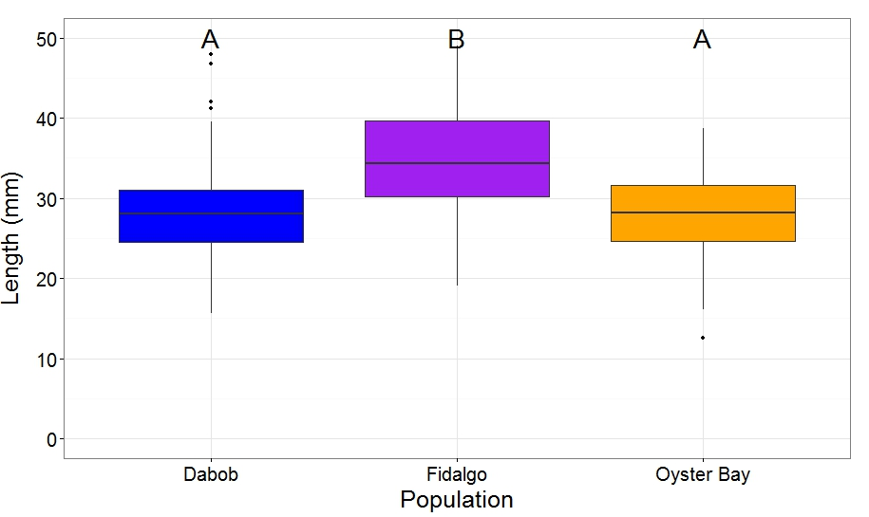
Figure 5. Oyster Size in September 2014 at Oyster Bay. Boxplots with mean size as central line and boxes represent second and third quartile. Horizontal lines are 1st and 4th quartile with dots representing outliers from data set. Letters indicate significant differences.

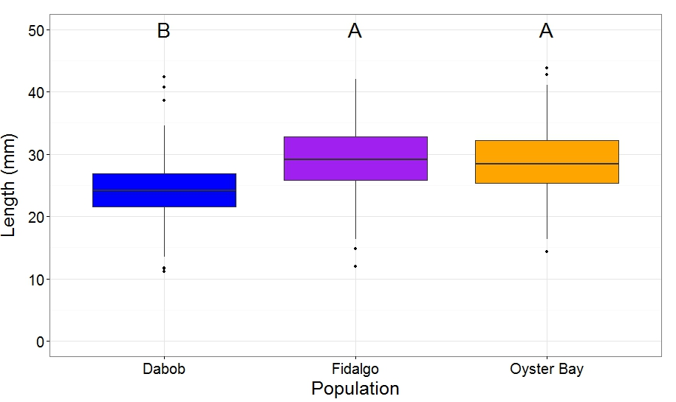
Figure 6. Oyster Size in October 2014 at Fidalgo Bay. Boxplots with mean size as central line and boxes represent second and third quartile. Horizontal lines are 1st and 4th quartile with dots representing outliers from data set. Letters indicate significant differences.

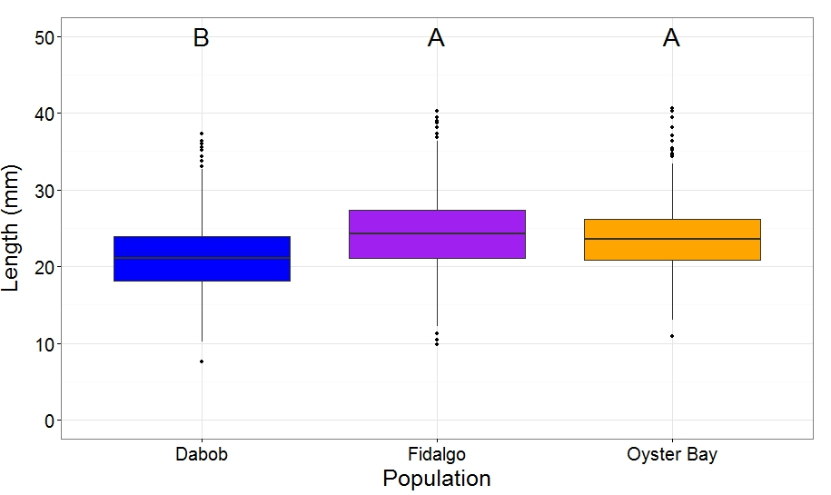
Figure 7. Oyster Size in October 2014 at Manchester. Boxplots with mean size as central line and boxes represent second and third quartile. Horizontal lines are 1st and 4th quartile with dots representing outliers from data set. Letters indicate significant differences.

3.4 Brooding females
The numbers of brooding females at each site varied with the largest number of brooding females present at Oyster Bay (Fig. 8) and the least amount of brooding females at Manchester (Fig. 10). The Oyster Bay population produced the highest number of brooding females at all locations.
The first brooding female at Oyster Bay was discovered on May 29 (Fig. 8). The native population (Oyster Bay) reached peak brooding by June 19th while Dabob and Fidalgo populations peaked on July 10. The first brooding female at Fidalgo was discovered on June 6th, from the Fidalgo population (Fig. 9). At Fidalgo, the Oyster Bay population reached peak brooding by July 11th while Fidalgo and Dabob populations did not reach peak brooding until August 8th. Manchester did not produced a brooding female until June 18th from the Oyster Bay population (Fig. 10). At Manchester, Oyster Bay and Dabob populations reached peak brooding on August 6th. The smallest average size and minimum individual size at brooding, 19.1+/-3.7 mm and 15 mm respectively, was observed at Manchester from the Dabob population.

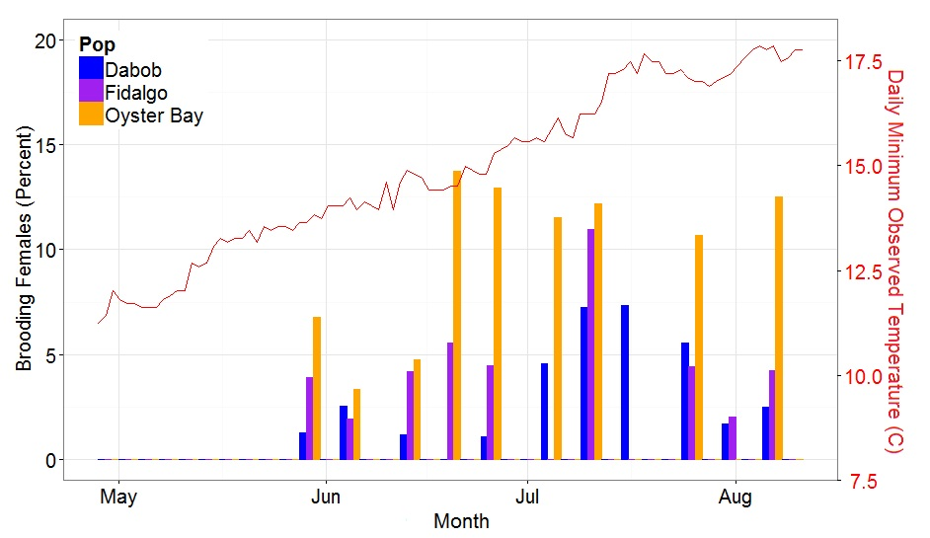
Figure 8. Percent Brooding Females from Each Population at Each Sample Date at Oyster Bay. Percent determined by number of brooding females (Br) divided by number of open oysters (T) or %=(Br/T)*100. Blue = Dabob, Purple = Fidalgo, Orange = Oyster Bay.

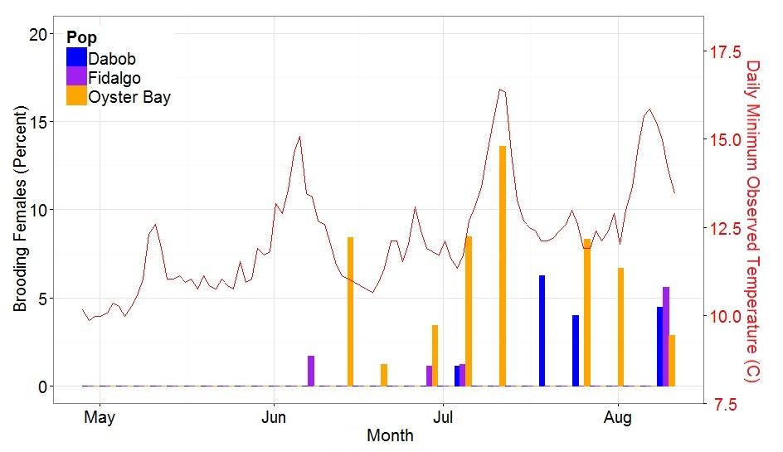
Figure 9. Percent Brooding Females from Each Population at Each Sample Date at Fidalgo. Percent determined by number of brooding females (Br) divided by number of open oysters (T) or %=(Br/T)*100. Blue = Dabob, Purple = Fidalgo, Orange = Oyster Bay.

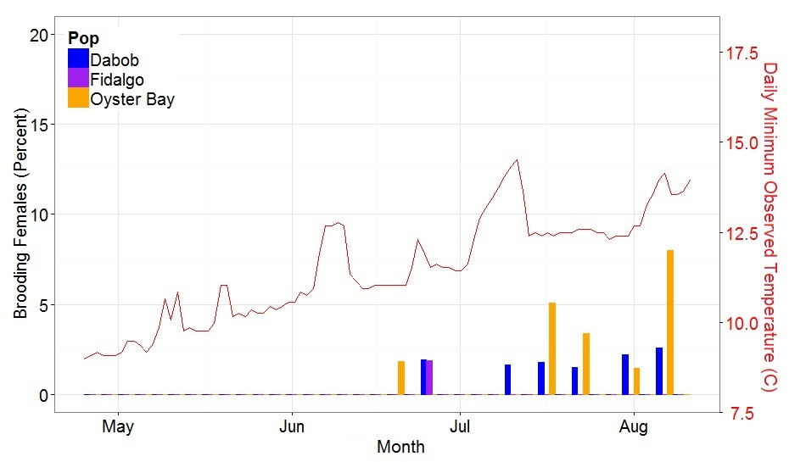
Figure 10. Percent Brooding Females from Each Population at Each Sample Date at Manchester. Percent determined by number of brooding females (Br) divided by number of open oysters (T) or %=(Br/T)*100. Blue = Dabob, Purple = Fidalgo, Orange = Oyster Bay.

In order to evaluate to role of temperature on brooding activity the number of degree days to peak brooding events was calculated at the two location where oysters were selected from and used in the experiment (Fidalgo and Oyster Bay). Oyster Bay brooding activity peaked at 308 degree days at Oyster Bay and 354 degree days at Fidalgo Bay. The other two populations, Dabob and Fidalgo, both took a greater number of degree days to reach peak reproductive activity. Both the Dabob and Fidalgo populations peaked at population brooding activity peaked at 453 and 513 degree days at Oyster Bay and Fidalgo Bay, respectively.

4. Discussion
The reciprocal transplant of Olympia oysters at distinct Puget Sound Washington locations yielded important new information on basic life history characteristics, including maturation as female in the first year of life, and first year average fecundity. Differential performance of populations in diverse environments suggest the existence of local adaptation in Olympia oyster populations. Ostrea lurida from a relatively harsh home site environment with low primary production and high dynamic habitats exhibited generally greater survival at all sites, whereas those from a relatively lush home site environment with high primary production and lower habitat dynamics exhibited generally greater reproductive activity at all sites. Populations from sites with shorter growing seasons exhibited greater growth in areas with longer growing periods which suggest a countergradient adaptation may have occurred in these populations.

4.1 Ostrea lurida Life History

4.1.1 Mortality
Temperature appears to be a likely factor affecting mortality in Olympia oysters. This observation is consistent with the review from Couch and Hassler (1989); these authors described the average temperature range in the Puget Sound experienced by O. lurida as 5 ℃ to 20 ℃. In the present study, populations growing at sites with more days that exceeded this range exhibited increased mortality.
The overall high mortality observed at Dabob Bay may likely be attributed to temperature. The Dabob Bay site exceeded the putative range on 35% of the total days (85 out of 242 days) with two subfreezing events of -0.78 ℃ and -3.3 ℃ in December 2013 and February 2014 respectively. The Oyster Bay site had a total of 39 days outside of the putative 5-20 ℃ range. The majority (34 days) were above the upper limit (20 ℃) but not near the lethal temperature (LT50) of 39 ℃ (Wasson et al., 2014); Oyster Bay had the second highest mortality rate of all sites though this cannot be fully explained by temperature. Fidalgo Bay had 24 days outside the thermal tolerance range, the majority (20 days) were under 5 ℃ but remained above freezing. These temperatures, albeit low, appear to have been transient enough to have little effect on overall mortality. The Manchester site remained within the thermal tolerance range, and had the highest survival of all sites.
Overall, temperature appears to affect mortality, with elevated temperatures more detrimental to survival. Burford et al. (2014) showed that environmental gradients, especially temperature, were most likely responsible for early life mortality at sites with more variation and higher temperatures. The average temperature range proposed by Couch and Hassler (1989) appear accurate, and the data presented here suggests that subfreezing temperatures are more likely to cause winter mortality.

4.1.2 Growth
Temperature is known to affect primary production necessary for oyster growth. In general, primary production at lower temperatures is less than that of higher temperatures. Overall growth in each area appears to have been influenced by the amount of available energy within the environment for consumption and growth.
Data presented here demonstrates that O. lurida populations can attain an average size of 35.8 mm +/-6.4 (SE=0.594, SD=6.401, CI=1.177) during the first year of growth. Some fast growing individuals attained sizes >45 mm. These data stand in contrast to previous research that stated O. lurida reach 35-45 mm in size in 2-3 years in South Puget Sound (Hopkins, 1936). It is important to note that at the Manchester site, with lower average summer temperatures, all populations averaged just above 20 mm within a year.

4.1.3 Reproduction
In this study, data presented here indicate that O. lurida reproduce as females in the first year of growth, at a minimum size of 15 mm. The average size of brooding females was 27.14 +/- 4.46 mm (SE=0.311, SD=4.46, CI=0.613). This result is surprising, given previous research (Hopkins, 1936; Coe, 1931; Couch and Hassler, 1989; Baker, 1995) that describes O. lurida as being unable to reproduce as females until at least their second year (Coe, 1931) at sizes of 35 mm or greater (Coe, 1931; Hopkins, 1936; Baker, 1995). Hopkins et al. (1936) stated 200-300 thousand larvae comprised broods from 2+ year old O. lurida. Counts of larvae from females in their first year produced smaller broods on average (~28,335 larvae) but some of the one year old females produced large broods (~137,627 larvae), roughly equivalent to those of O. lurida >2 years old, suggesting that some individuals may reach peak fecundity in their first year, much earlier than previously described.
It has been generally accepted that O. lurida begin spawning at relatively low temperatures (13 ℃ Coe, 1931; 12.5 ℃ Baker, 1995). Hopkins et al. (1936) suggested that this temperature threshold must occur during high tide, which is related to the daily minimum temperature. We found that at all sites brooding only occurred after several days (4+) of daily minimum temperatures above 12.5 ℃. At Oyster Bay, daily minimum temperatures continuously increased and near constant brooding was observed at this site for the majority of the season. On the other hand, Fidalgo Bay oscillated around the 12.5 ℃ mark for a large portion of the sampling period due to tidal influence. Only after the site stabilized above 12.5 ℃, did oysters brood with regularity. Daily minimum temperatures at Manchester were essentially at the 12.5 ℃ threshold for the majority of the sampling period, and very few brooding oysters were observed at this site. Whether temperature is a direct (degree days) or indirect (primary productivity) effect is unclear, and remains to be investigated.

4.2 Population Differences

4.2.1 Mortality
Survival differed significantly among populations. At all transplant sites, the population derived from Dabob Bay parents exhibited better survival than the other two populations; this difference was statistically significant at three of the four transplant sites.
The increased survival of the Dabob population could be a function of increased stress resilience in response to prevalent temperature extremes found within their native habitat at Dabob Bay. Sørensen et al. (2004), found that many species exhibit heritable heat shock protein production patterns. Somero (2002) compared heat shock pathways in high intertidal species typically exposed to greater temperature variation to low intertidal species. Somero (2002) found that animals that experience lower temperature variation typically induce heat shock pathways at lower temperature limits which is energetically costly and often induces high mortality in highly variable sites. In the Dabob population the higher survival rates observed may be an energetic cost associated with the observed lower reproductive activity in this population.

4.2.2 Growth
At all transplant sites, the population derived from Dabob Bay parents exhibited the least amount of growth. This observation may be due to energetic tradeoffs for improved survival as described above. Applebaum et al. (2014) found that energetic trade offs may improve survival, a fitness component, over growth. Arendt (1997) showed that “stress tolerators” exhibit slower intrinsic growth that is relatively unresponsive to improved conditions.
At Oyster Bay, oysters from Fidalgo grew significantly larger than the native population mostly likely due to a countergradient adaptation which allowed for improved nutrient intake and/or energy efficiency. One explanation to why the Fidalgo oysters grew better than their native counterparts at Oyster Bay is that the Fidalgo oysters may have adapted to grow at a more efficient rate given the short growing season in Fidalgo Bay. This is consistent to what Savolainen et al. (2007) found with trees native to northern latitudes transplanted to southern latitudes; the northern populations experience intense prolonged growth due to the longer growing season in southern latitudes. Dittman et al. (1997) found that Crassostrea virginica from colder northern latitudes had significantly more ciliary activity suggesting that they had adapted to feed more actively at colder temperatures. Yamahira and Conover (2002) showed that northern latitude Menidia menidia had a faster growth rate and better overall growth in areas with warmer temperatures.

4.2.3 Reproduction
At all transplant sites, the Oyster Bay population had greater proportion of brooding females than the other two populations. This pattern was statistically significant at the Fidalgo Bay and Oyster Bay sites and evident, despite the overall low number of brooding females, at the Manchester site.
The greater number of brooding females produced by the Oyster Bay population may be an energetic trade off to improve early season reproductive success. In addition to a greater proportion of brooding females, the Oyster Bay population reached a spawning peak at 308 and 354 degree days at Oyster Bay and Fidalgo Bay, respectively, much earlier than the other two populations both of which reached the peak at 453 and 513 degree days at each site, respectively. Enriquez-Diaz et al. (2009) found that C. gigas from a southern embayment spawned 30 days earlier than those from a northern embayment located along the west coast of France in a latitudinal gradient. In comparison, our data shows that while all populations began spawning at roughly the same time at each site, the Oyster Bay population reached peak brooding after approximately 30 days from initial spawning and 30 days earlier than the other two population’s peak at two sites. Both spawn timing and abundance of spawners are fitness correlates in O. lurida (Oates, 2013), salmon spp. (Araki et al., 2008), and Scleractinian coral species (Baird et al., 2009) because they influence reproductive success (Wright and Trippel, 2009). Spawn timing has been assumed to be a heritable trait via population in many marine species (review by Palumbi, 1994) including salmon spp. (Quinn et al., 2007) and Eastern oysters, C. virginica (Barber et al., 1991). Spawn timing may have developed in response to environmental variables most suitable for offspring survival (Barber et al., 1991).

4.3 Conclusion
In conclusion, significant differences in life history traits among Ostrea lurida populations within Puget Sound Washington demonstrate adaptations possibly linked with environmental cues. Adaptations such as the high survival of the Dabob population may be due to extreme environmental variation at their home site. While the greater proportion of brooding females in the Oyster Bay population is likely related to temperature trends at their home site. Finally the high growth in the Fidalgo population is probably related to shorter growing seasons at their home site. These findings have implications for ongoing restoration efforts as well as for future plans of study on the life history of Olympia oysters.

5. Acknowledgements
The authors thank Puget Sound Restoration Fund for all of their hard work collecting and conditioning broodstock, spawning and conditioning larvae, and assisting with sample retrieval. We thank L. Christine Savolainen, J. Allen, S. Bennett, J. Blais, S. Adams, C. Olson, S. White, Dr. M. Gavery, H. Wear, K. Jackson, D. Immerman, A. Jasonowicz, A. Godersky, J. Stevick, E. Maipi, J. Richards, and M. Hedberg. We also thank NOAA Fisheries, Washington Department of Fish and Wildlife, Washington Sea Grant, Crab Fresh Inc., The Fagergren Family, Fidalgo Marina, Rock Point Oyster Company, Taylor Shellfish, and University of Washington’s School of Aquatic and Fishery Science

6. References

Anderson P. 1995. Ecological restoration and creation: a review. Biological Journal of the Linnean Society 56:187–211.
Applebaum SL, Pan T-CF, Hedgecock D, Manahan DT. 2014. Separating the nature and nurture of the allocation of energy in response to global change. Integrative and Comparative Biology:icu062.
Araki H, Berejikian BA, Ford MJ, Blouin MS. 2008. Fitness of hatchery-reared salmonids in the wild. Evolutionary Applications 1:342–355.
Arendt JD. 1997. Adaptive intrinsic growth rates: An integration across taxa. The Quarterly Review of Biology 72:149–177.
Baird AH, Guest JR, Willis BL. 2009. Systematic and biogeographical patterns in the reproductive biology of scleractinian corals. Annual Review of Ecology, Evolution, and Systematics 40:551–571.
Baker P. 1995. Review of ecology and fishery of the Olympia oyster, Ostrea lurida, with annotated bibliography. Journal of Shellfish Research 14:503–518.
Barber BJ, Ford SE, Wargo RN. 1991. Genetic variation in the timing of gonadal maturation and spawning of the eastern oyster, Crassostrea virginica (Gmelin 1791). The Biological Bulletin 181:216–221.
Blake B, Bradbury A. 2012. Plan for rebuilding Olympia oyster (Ostrea lurida) populations in Puget Sound with a historical and contemporary overview.
Burford MO, Scarpa J, Cook BJ, Hare MP. 2014. Local adaptation of a marine invertebrate with a high dispersal potential: evidence from a reciprocal transplant experiment of the eastern oyster Crassostrea virginica. Marine Ecology Progress Series 505:161–175.
Camara MD, Vadopalas B. 2009. Genetic aspects of restoring Olympia oysters and other native bivalves: balancing the need for action, good intentions, and the risks of making things worse. Journal of Shellfish Research 28:121–145.
Coe WR. 1932a. Season of attachment and rate of growth of sedentary marine organisms at the pier of the Scripps Institution of Oceanography, La Jolla, California. Scripps Institution of Oceanography.
Coe WR. 1932b. Development of the gonads and the sequence of the sexual phases in the California oyster (Ostrea lurida). Scripps Institution of Oceanography.
Conover DO. 1998. Local adaptation in marine fishes: evidence and implications for stock enhancement. Bulletin of Marine Science 62:477–493.
Couch D, Hassler TJ. 1989. Species profiles: life histories and environmental requirements of coastal fishes and invertebrates (Pacific Northwest) OLYMPIA OYSTER.
Cushing DH. 1984. The gadoid outburst in the North Sea. Journal du Conseil 41:159–166.
Dittman DE. 1997. Latitudinal compensation in oyster ciliary activity. Functional Ecology 11:573–578.
Enríquez-Díaz M, Pouvreau S, Chávez-Villalba J, Pennec ML. 2009. Gametogenesis, reproductive investment, and spawning behavior of the Pacific giant oyster Crassostrea gigas: evidence of an environment-dependent strategy. Aquaculture International 17:491–506.
Grosjean P, Ibanez F, Etienne M. 2014. pastecs: Package for Analysis of Space-Time Ecological Series.
Heare J, Vadopalas B, Roberts SB. 2014. O. lurida Survey 2014. ZENODO. 10.5281/zenodo.13201
Hodgson S, Quinn TP. 2002. The timing of adult sockeye salmon migration into fresh water: adaptations by populations to prevailing thermal regimes. Canadian Journal of Zoology 80:542–555.
Hopkins AE. 1936. Ecological observations on spawning and early larval development in the Olympia oyster (Ostrea lurida). Ecology 17:551–566.
Joshi J, Schmid B, Caldeira MC, Dimitrakopoulos PG, Good J, Harris R, Hector A, Huss-Danell K, Jumpponen A, Minns A et al. 2001. Local adaptation enhances performance of common plant species. Ecology Letters 4:536–544.
Lotze HK, Coll M, Magera AM, Ward-Paige C, Airoldi L. 2011. Recovery of marine animal populations and ecosystems. Trends in Ecology & Evolution 26:595–605.
Mapbox. 2014.Data © OpenStreetMap contributors. Licensed under the Open Data Commons Open Database License. Design © Mapbox. Licensed according to the Mapbox Terms of Service. | Mapbox. Mapbox.
McGraw KA. 2009. The Olympia oyster, Ostrea lurida Carpenter 1864, along the west coast of North America. Journal of Shellfish Research 28:5–10.
McKay JK, Christian CE, Harrison S, Rice KJ. 2005. “How local is local?”—A review of practical and conceptual issues in the genetics of restoration. Restoration Ecology 13:432–440.
Oates M. 2013. Observations of gonad structure and gametogenic timing in a recovering population of Ostrea lurida (Carpenter 1864). Master Thesis. University of Oregon. USA
O’Malley KG, Ford MJ, Hard JJ. 2010. Clock polymorphism in Pacific salmon: evidence for variable selection along a latitudinal gradient. Proceedings of the Royal Society of London B: Biological Sciences 277:3703–3714.
Palumbi SR. 1994. Genetic divergence, reproductive isolation, and marine speciation. Annual Review of Ecology and Systematics 25:547–572.
Pohlert T. 2014. PMCMR: Calculate Pairwise Multiple Comparisons of Mean Rank Sums.
Quinn TP, Unwin MJ, Kinnison MT. 2000. Evolution of temporal isolation in the wild: Genetic divergence in timing of migration and breeding by introduced chinook salmon populations. Evolution 54:1372–1385.
R: A Language and Environment for Statistical Computing 2013. Vienna, Austria: R Foundation for Statistical Computing.
Rasband W. 2010. ImageJ Image Processing Program. MD, USA: National Institute of Health.
Sanford E, Kelly MW. 2011. Local adaptation in marine invertebrates. Annual Review of Marine Science 3:509–535.
Savolainen O, Pyhäjärvi T, Knürr T. 2007. Gene flow and local adaptation in trees. Annual Review of Ecology, Evolution, and Systematics 38:595–619.
Somero GN. 2002. Thermal physiology and vertical zonation of intertidal animals: optima, limits, and costs of living. Integrative and Comparative Biology 42:780–789.
Sørensen JG, Kristensen TN, Loeschcke V. 2003. The evolutionary and ecological role of heat shock proteins. Ecology Letters 6:1025–1037.
Therneau TM, 2014. survival: Survival Analysis.
Wasson K, Zabin C, Bible J, Ceballos E, Chang A, Cheng B, Deck A, Grosholz T, Latta M, Ferner M. 2014. New guide to Olympia oyster restoration and conservation « Oyster Restoration Workgroup.
White J, Ruesink JL, Trimble AC. 2009. The nearly forgotten oyster: Ostrea lurida Carpenter 1864 (Olympia oyster) history and management in Washington State. Journal of Shellfish Research 28:43–49.
Wickham H. 2014. plyr: Tools for splitting, applying and combining data.
Wickham H, Chang W. 2014. ggplot2: An implementation of the Grammar of Graphics.
Wright PJ, Trippel EA. 2009. Fishery-induced demographic changes in the timing of spawning: consequences for reproductive success. Fish and Fisheries 10:283–304.
Yamahira K, Conover DO. 2002. Intra- vs. interspecific latitudinal variation in growth: adaptation to temperature or seasonality? Ecology 83:1252–1262.

